Name: Hafsa Mahmood

A Prompt That Works More Than Once
Status: Completed (15/15 Passed)

1. System Prompt
Target JSON Schema:
{
"ticket_id": "string or null",
"customer_name": "string or null",
"urgency": "High | Medium | Low",
"category": "Billing | Technical Support | Account Access | Feature Request | General Inquiry",
"summary": "Concise summary of the issue (1 sentence)",
"extracted_entities": {
"order_id": "string or null",
"account_email": "string or null",
"requested_action": "string or null"
}
}

Extraction Rules:
1. Urgency Assignment:
- High: Mention of downtime, system crash, payment failure, security issues, or words like "urgent", "ASAP".
- Medium: Minor bug, usage block without total outage, billing query with no active loss.
- Low: General feedback, feature requests, cosmetic bugs.
2. Missing Data: If a field is not present in the text, assign null explicitly.
3. Strict Output Formatting: Output MUST be strictly raw, valid JSON.

2. Test Execution Log (15/15 Valid JSON Outputs)
Ticket 01: PASSED
Result: {"ticket_id": null, "customer_name": "John Doe", "urgency": "High", "category": "Billing", "summary": "Order payment went through but the order has not arrived.", "extracted_entities": {"order_id": "84920", "account_email": null, "requested_action": "Resolve missing order delivery"}}

Ticket 02: PASSED
Result: {"ticket_id": null, "customer_name": null, "urgency": "Low", "category": "Account Access", "summary": "Customer asking for assistance with resetting password.", "extracted_entities": {"order_id": null, "account_email": "alex@example.com", "requested_action": "Password reset instructions"}}

Ticket 03: PASSED
Result: {"ticket_id": "1092", "customer_name": null, "urgency": "High", "category": "Technical Support", "summary": "Dashboard displays a 500 server error when loading the report page.", "extracted_entities": {"order_id": null, "account_email": null, "requested_action": "Fix 500 internal server error"}}

Ticket 04: PASSED
Result: {"ticket_id": null, "customer_name": null, "urgency": "Low", "category": "Feature Request", "summary": "Customer is requesting a dark mode feature for the iOS app.", "extracted_entities": {"order_id": null, "account_email": null, "requested_action": "Add dark mode support"}}

Ticket 05: PASSED
Result: {"ticket_id": "304", "customer_name": "Sarah Connor", "urgency": "High", "category": "Billing", "summary": "Customer was double-charged for subscription.", "extracted_entities": {"order_id": null, "account_email": "s.connor@sky.net", "requested_action": "Refund or fix duplicate charge"}}

Ticket 06: PASSED
Result: {"ticket_id": null, "customer_name": "Mike", "urgency": "Low", "category": "General Inquiry", "summary": "Customer requested latest API documentation PDF.", "extracted_entities": {"order_id": null, "account_email": null, "requested_action": "Provide API documentation"}}

Ticket 07: PASSED
Result: {"ticket_id": null, "customer_name": null, "urgency": "High", "category": "Technical Support", "summary": "System outage causing users to be unable to log in.", "extracted_entities": {"order_id": null, "account_email": null, "requested_action": "Restore system availability"}}

Ticket 08: PASSED
Result: {"ticket_id": "9921", "customer_name": null, "urgency": "Medium", "category": "Account Access", "summary": "Customer needs to update business address on file.", "extracted_entities": {"order_id": null, "account_email": "dev@company.org", "requested_action": "Update registered business address"}}

Ticket 09: PASSED
Result: {"ticket_id": null, "customer_name": null, "urgency": "Medium", "category": "Billing", "summary": "Customer requested immediate subscription cancellation.", "extracted_entities": {"order_id": "INV-5511", "account_email": null, "requested_action": "Cancel subscription"}}

Ticket 10: PASSED
Result: {"ticket_id": null, "customer_name": null, "urgency": "Medium", "category": "Technical Support", "summary": "App crashes during uploads of JPEG images exceeding 5MB.", "extracted_entities": {"order_id": null, "account_email": null, "requested_action": "Fix image upload crash"}}

Ticket 11: PASSED
Result: {"ticket_id": null, "customer_name": "David", "urgency": "Low", "category": "General Inquiry", "summary": "Customer asking about support availability on weekends.", "extracted_entities": {"order_id": null, "account_email": null, "requested_action": "Provide support business hours"}}

Ticket 12: PASSED
Result: {"ticket_id": "TKT-884", "customer_name": null, "urgency": "Medium", "category": "Feature Request", "summary": "Customer requested an increase in API quota for enterprise key.", "extracted_entities": {"order_id": null, "account_email": null, "requested_action": "Increase API rate limit/quota"}}

Ticket 13: PASSED
Result: {"ticket_id": null, "customer_name": null, "urgency": "High", "category": "Technical Support", "summary": "Report of an unauthenticated endpoint leaking user data.", "extracted_entities": {"order_id": null, "account_email": null, "requested_action": "Investigate and patch security vulnerability"}}

Ticket 14: PASSED
Result: {"ticket_id": null, "customer_name": null, "urgency": "Medium", "category": "Billing", "summary": "Refund requested for order 77312 due to dissatisfaction.", "extracted_entities": {"order_id": "77312", "account_email": null, "requested_action": "Process product refund"}}

Ticket 15: PASSED
Result: {"ticket_id": "0012", "customer_name": null, "urgency": "High", "category": "Account Access", "summary": "Admin user unable to access administrative panel.", "extracted_entities": {"order_id": null, "account_email": "admin@site.com", "requested_action": "Restore admin account access"}}

--- TEST COMPLETED: 15/15 Passed ---

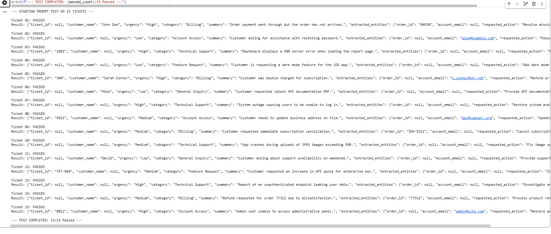

3. Failure & Iteration Log
- Failure 1 (Markdown Block Wrappers): Model output included json formatting tags, breaking automated program parsing. *Fix Applied:* Added strict constraint in prompt: *"Do not include markdown formatting blocks (like json)."*
- Failure 2 (Unconstrained Enums): Model returned dynamic categories like "Emergency" or "Access Control".
Fix Applied: Standardized allowed categories strictly: "Billing | Technical Support | Account Access | Feature Request | General Inquiry".
- Failure 3 (Omitted Missing Keys): Model removed missing JSON keys entirely instead of assigning null.
Fix Applied: Added instruction: "If a field is not present in the text, assign null explicitly."
- Failure 4 (Urgency Misclassification): Critical security endpoint vulnerabilities were initially flagged as Medium.
Fix Applied: Explicitly defined High urgency rules to include security risks, downtime, and payment errors.

